Justice For #EachGeneration Worship Service
Solidarity with the Youth Awakening a Nation to Climate Action
Prepared by Rev. Tracy Howe Wispelwey

Contextual Notes:

What follows is a worship service originally prepared for the Shenandoah Association of the United Church of Christ in Central Virginia. To help others adapt the service to their own local contexts, a list of online resources is provided at the end. You can easily search for the following information:

The service that follows links worship to the words and experiences of the 21 youth plaintiffs in Juliana v. U.S. Learn more about the youth on the Our Children’s Trust website.

Call to Worship

"Climate change is the defining issue of our time. The actions those in power take and decisions they make today, will determine the kind of world future generations inherit. (Xiuhtezcatl Tonatiuh Martinez)
God is gracious and merciful,
slow to anger and abounding in steadfast love.
"Climate change isn't just about temperatures and weather, it's about people. Our earth will be here for millennia, it's up to us to decide if humanity will be too." (Victoria Barrett)
God is good to all,
Compassionate over all creation
"We need to protect our land, water, air, and wildlife. Our government is turning a blind eye to our planet, and our future." (Hazel Van Ummersen)
Creator is faithful in all words,
Gracious in all deeds,
Upholds all who are falling
Raises up all who are bowed down.

Let us worship and be filled for the struggle!

HYMN: Awake, Awake to Love and Work (89 New Century Hymnal)

A Responsive Psalm Reading

Psalm 145 Adapted

I will speak about you, Creator, and about your beloved Creation
and bless your name and work forever and ever.
Every day I will bless and speak;
we bless your name and work forever and ever.
Great is the Living God, greatness unsearchable, and greatly to be praised;
we bless your name and work forever and ever.
One generation shall declare your works to another,
that each generation will live and thrive.
One generation shall declare the glorious splendor of your majesty,
that each generation will live and thrive.
One generation shall declare the might of your awesome deeds,
that each generation will live and thrive.
One generation shall celebrate your abundant goodness,
that each generation will live and thrive.

The Lord is gracious and merciful,
slow to anger and abounding in steadfast love.
The Lord is good to all,
and compassionate over all creation.
All your works shall give thanks to you, O Lord,
and all your faithful shall bless you.
We will speak of the glory of your reign, and tell of your power,
that each generation will live and thrive.
to make known to all people your justice and beauty,
that each generation will live and thrive.
Your dream of justice and beauty are everlasting,
and endures throughout all generations,
that each generation will live and thrive.
The Lord is faithful in all words, and gracious in all deeds,
that each generation will live and thrive.
The Lord upholds all who are falling, and raises up all who are bowed down,
that each generation will live and thrive.
The eyes of all look to you, and you give them their food in due season.
that each generation will live and thrive.
You open your hand, satisfying the desire of every living thing.
that each generation will live and thrive.
The Lord is just in all ways, and kind in his doings.
that each generation will live and thrive.
The Lord is near to all who call in truth.
We call to you God, we have caused the climate to change.
God hears their cry.
We cry to you God, we have already lost and destroyed so much.
The Lord watches over all, but will destroy the wicked.
Destroy the wickedness of greed, of exploitation, of selfishness and of waste. Give us
courage and resolve to change, that each generation will live and thrive.

SONG Ain’t Gonna Let Nobody Turn Me ‘Round freedom song adapted

Ain't gonna let nobody turn me around
Turn me around, turn me around
Ain't gonna let nobody turn me around
Gonna keep on a-walkin', keep on a-talkin'
Marchin’ on to Freedom-land

Ain't gonna let the administration…
Ain't gonna let no policy…
Ain't gonna let oil companies…

We’re here, and we’re fighting for everyone
Everyone, everyone
We’re here and we’re fighting for everyone
We all share this planet, got to love it, protect it
So we can build a Freedom-land

Litany for the Youth of Our Children’s Trust

For Xiuhtezcatl (pronounced “Shu-TEZ-caht”), the Aztec people, and indigenous groups everywhere, for the mountains and rivers of Colorado facing the pestilence of foreign species, fires and drought…

God, plant us in the movement for justice, to stop climate change and protect creation.

For Kelsey, Cascadia and the Pacific Northwest, a land increasingly impacted by wildfires, ocean acidification, and heat waves…

God, plant us in the movement for justice, to stop climate change and protect creation.

For Miko, the Marshall Islands and all islands in the Pacific and all Pacific Islander Peoples on the frontlines of rising tides and climate change…

God, plant us in the movement for justice, to stop climate change and protect creation.

For Levi, the barrier islands of Florida, the sea life being impacted by red algal blooms and all in the paths of increasing storms and hurricanes…

God, plant us in the movement for justice, to stop climate change and protect creation.

For Tia, Kiran and Isaac, the mountains of Oregon facing record low snowfall and summer droughts and the communities around the state impacted and those trying to free themselves from fossil fuels…

God, plant us in the movement for justice, to stop climate change and protect creation.

For Sahara, Hazel, Avery and Zealand, the decreasing water levels of the Mohawk River in Oregon and increasing sea levels on the coasts, the animals that are endangered throughout the Pacific Northwest…

God, plant us in the movement for justice, to stop climate change and protect creation.

For Victoria, the low lying land of New York City and the coastal areas threatened by increasing storm intensity in all seasons…

God, plant us in the movement for justice, to stop climate change and protect creation.

For Journey, his native Sioux people and lands as well as his adopted culture and land in Hawaii and the communities seeing shrinking beaches, dying coral reefs and drought and live threatened by complete submersion by the end of the century…

God, plant us in the movement for justice, to stop climate change and protect creation.

For Jaime, her native Dineh people, the communities of Arizona, and the Navajo Nation facing water scarcity, the cultural and spiritual impacts of climate change…

God, plant us in the movement for justice, to stop climate change and protect creation.

For Jayden, the people and land of Louisiana, facing what should be 500 and 1,000-year floods multiple times a year and those whose health is diminished because of pollution and fossil fuel development…

God, plant us in the movement for justice, to stop climate change and protect creation.

For Nathan, the people and land of Alaska where severe winter ice storms and summer wildfires are changing the land, water and air…

God, plant us in the movement for justice, to stop climate change and protect creation.

For Aji, for ancient trees that need protection and for those fighting to protect forests and plant new ones…

God, plant us in the movement for justice, to stop climate change and protect creation.

For Sophie and for children whose lives are disrupted by climate change, who miss school in the wake of increasing storms, and who are losing their spaces to encounter creation and living eco systems…

God, plant us in the movement for justice, to stop climate change and protect creation.

For Nick and those called by their faith to protect the earth…

God, plant us in the movement for justice, to stop climate change and protect creation.

For Jacob and those pioneering sustainable ways of farming and agriculture even as climate change makes it harder, and for those fighting pipelines and pollution from industrialized agriculture…

God, plant us in the movement for justice, to stop climate change and protect creation.

For Alex and young people committed to studying earth sciences and working for an end to climate change…

God, plant us in the movement for justice, to stop climate change and protect creation.

For our youth bringing legal action in states and at the national level, on behalf of all of us…

Let us support them and stand with them, so each generation will know you and your goodness God.

Silence

A Reading Job 12:7-10

But ask the animals, and they will teach you;
the birds of the air, and they will tell you;
ask the plants of the earth, and they will teach you;
and the fish of the sea will declare to you.
Who among all these does not know
that the hand of the Lord has done this?
In his hand is the life of every living thing
and the breath of every human being.

Pass the Peace

*See also the passing of the peace rituals from Mission 4/1 Earth

SONG Call to Nonviolence Tracy Howe Wispelwey
*used with permission

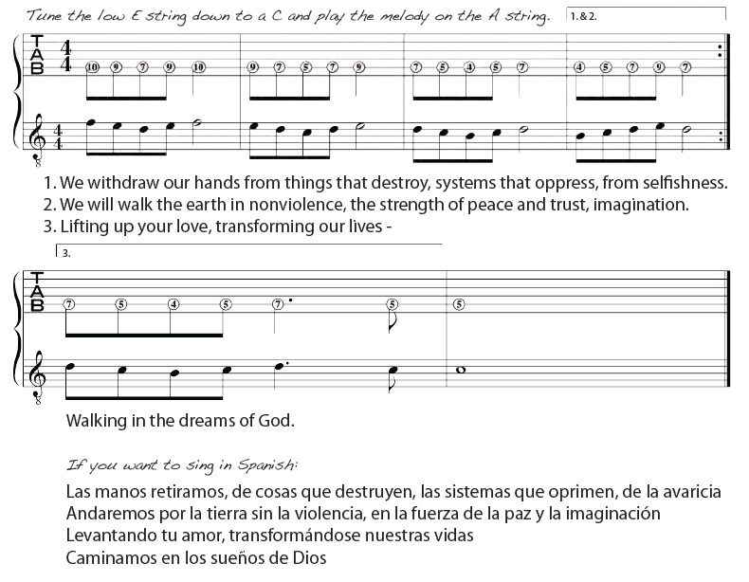

***Recording and Song Download Available at: https://restorationvillagearts.bandcamp.com/track/call-to-nonviolence

Resources of Contextualizing Your Worship Service to Your Own Locality

-Identify the watershed you are in and learn about its health. https://cfpub.epa.gov/surf/locate/index.cfm

-Identify the original First Nations people groups of your region.
http://www.native-languages.org/states.htm

-Identify how and where your city’s electricity is generated and challenges to establishing renewable energy in your area.
http://www.energyjustice.net/map/localmap

-Learn about waste treatment in your area and what communities live in proximity to waste sites.
http://www.energyjustice.net/map/localmap

-Research what animals are endangered in your area or have gone extinct.
https://www.fws.gov/Endangered/map/index.html

-More Research Resources:
http://www.ucc.org/your_one_stop_shop_for_research_resources

Continuing the Journey:

How to Become a Creation Justice Church:
http://www.ucc.org/how_it_works_becoming_a_creation_justice_church
Additional Resources:

Mission 4/1 Earth http://www.ucc.org/earth/resources.html

